13/08/2024 JAVA-CSA0983

**1.MOUSEEVENTHANDLER:**

package mouseeventhandler;

import javafx.application.Application;

import javafx.event.EventHandler;

import javafx.scene.Group;

import javafx.scene.Scene;

import javafx.scene.control.TextField;

import javafx.scene.input.KeyEvent;

import javafx.scene.paint.Color;

import javafx.stage.Stage;

public class Mouseeventhandler extends Application {

@Override

public void start(Stage primaryStage) throws Exception {

// TODO Auto-generated method stub

//Creating TextFields and setting position for them

TextField tf1 = new TextField();

TextField tf2 = new TextField();

tf1.setTranslateX(100);

tf1.setTranslateY(100);

tf2.setTranslateX(300);

tf2.setTranslateY(100);

//Handling KeyEvent for textfield 1

tf1.setOnKeyPressed(new EventHandler<KeyEvent>() {

@Override

public void handle(KeyEvent key) {

// TODO Auto-generated method stub

tf2.setText("Key Pressed :"+" "+key.getText());

}

});

//setting group and scene

Group root = new Group();

root.getChildren().addAll(tf2,tf1);

Scene scene = new Scene(root,500,200,Color.WHEAT);

primaryStage.setScene(scene);

primaryStage.setTitle("Handling KeyEvent");

primaryStage.show();

}

public static void main(String[] args) {

launch(args);

}

}

OUTPUT:

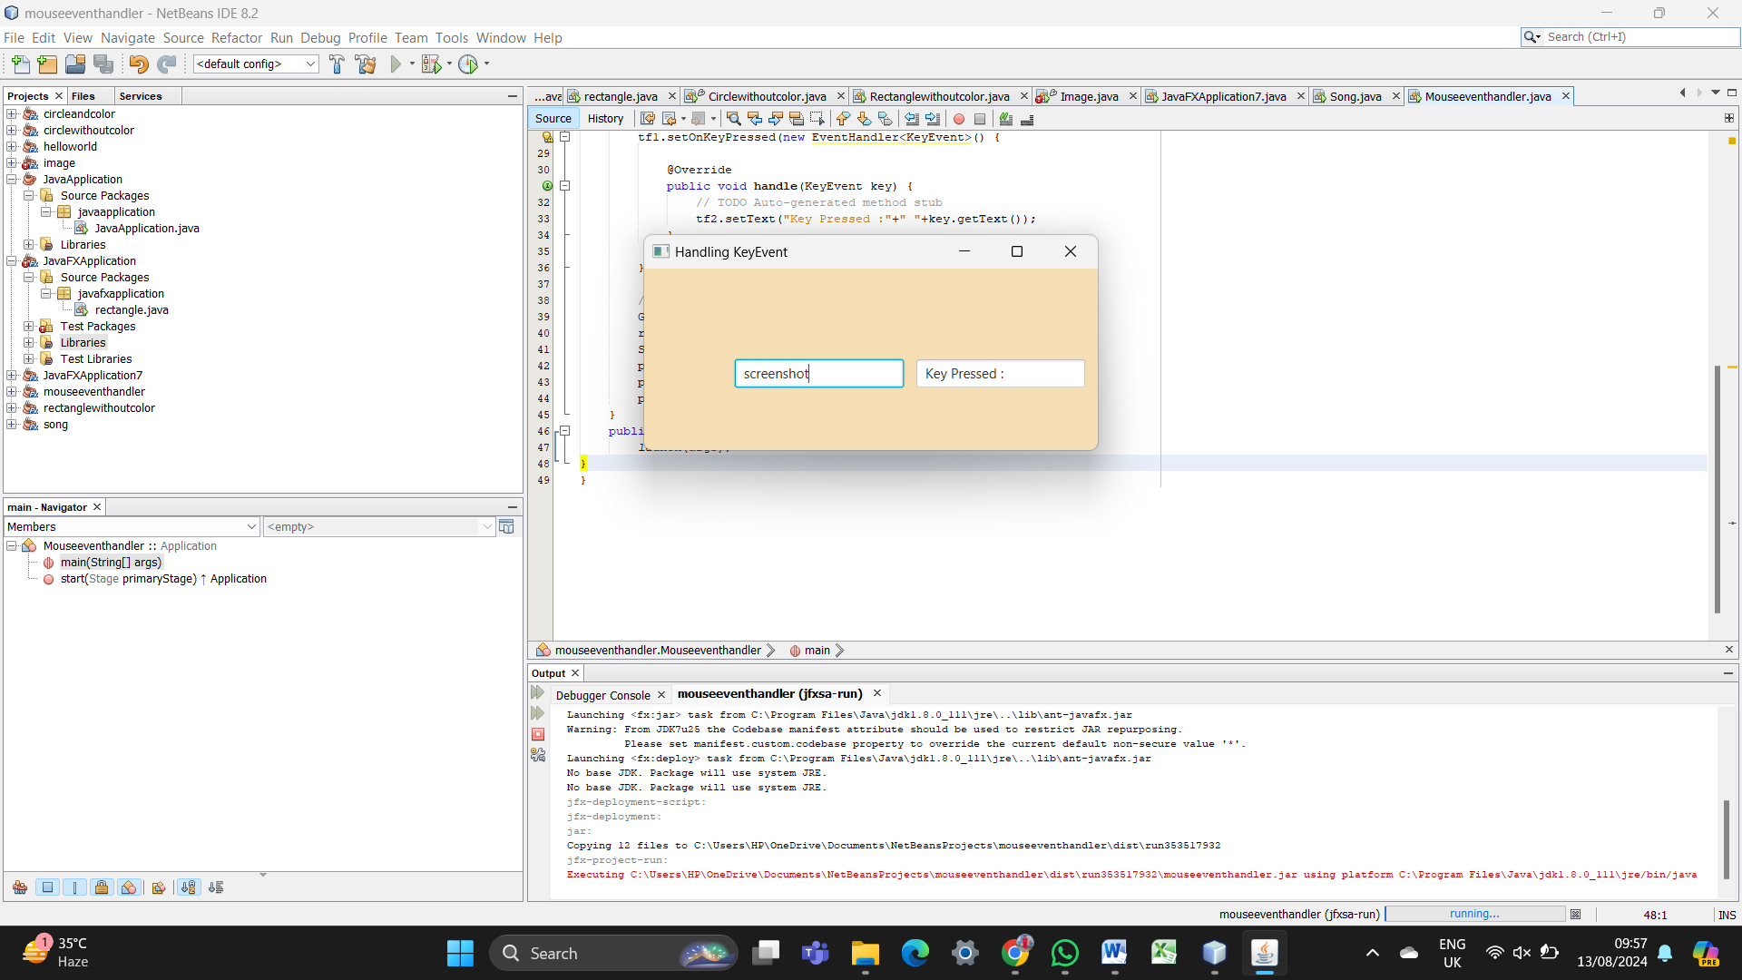

**2.IMAGE ADDING:**

package javafxapplication7;

import javafx.application.Application;

import javafx.scene.Scene;

import javafx.scene.image.Image;

import javafx.scene.image.ImageView;

import javafx.scene.layout.StackPane;

import javafx.stage.Stage;

public class JavaFXApplication7 extends Application {

@Override

public void start(Stage primaryStage) {

Image image = new Image("file:C:\\Users\\HP\\Downloads\\WhatsApp Image 2024-08-13 at 08.53.08_3b377215.jpg");

//C:\\Users\\HP\\Downloads\\WhatsApp Image 2024-08-13 at 08.53.08_3b377215.jpg

ImageView imageView = new ImageView(image);

imageView.setFitWidth(290);

imageView.setFitHeight(350);

imageView.setPreserveRatio(true);

StackPane root = new StackPane();

root.getChildren().add(imageView);

Scene scene = new Scene(root, 300, 250);

primaryStage.setTitle("Display Image");

primaryStage.setScene(scene);

primaryStage.show();

}

public static void main(String[] args) {

launch(args);

}

}

OUTPUT:

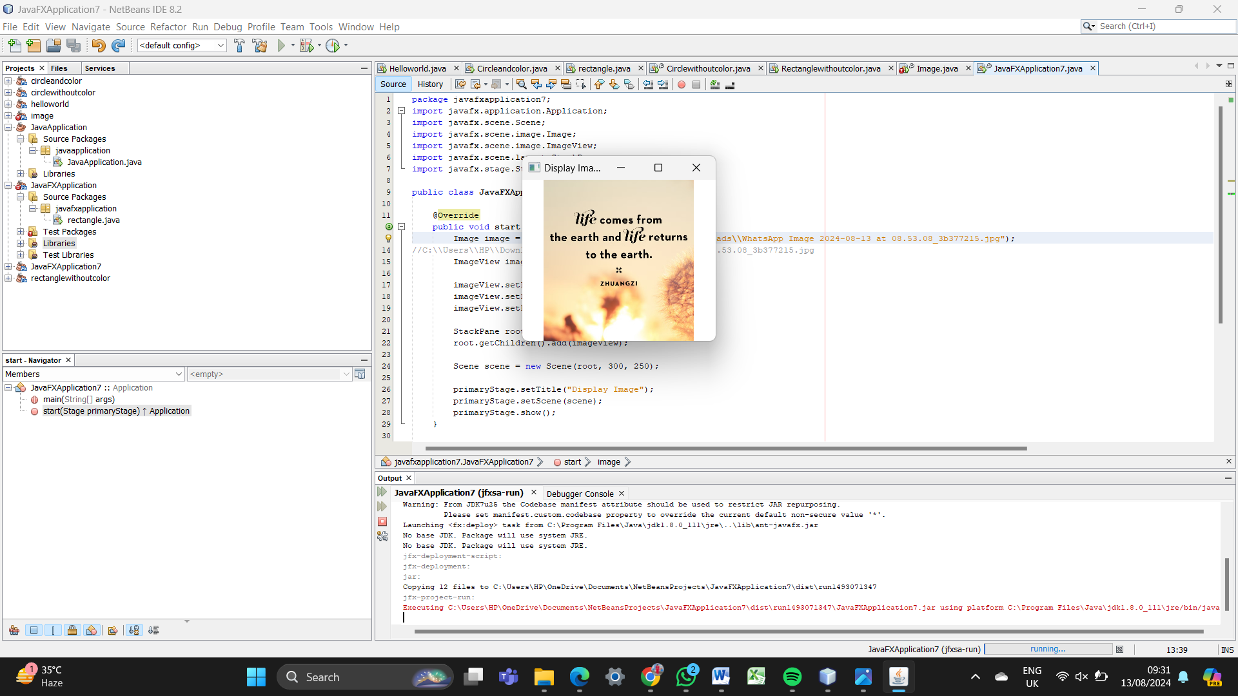

**3.ADDING AUDIO:**

package song;

import javafx.application.Application;

import javafx.event.ActionEvent;

import javafx.event.EventHandler;

import javafx.scene.Scene;

import javafx.scene.control.Button;

import javafx.scene.layout.StackPane;

import javafx.stage.Stage;

import javafx.scene.media.Media;

import javafx.scene.media.MediaPlayer;

import java.io.File;

public class Song extends Application {

@Override

public void start(Stage primaryStage) {

String audioFilePath = "C:\\Users\\HP\\Downloads\\Spark Song – Goat Movie _ BGM Ringtone Download - MobCup.Com.Co.mp3";

Media audio = new Media(new File(audioFilePath).toURI().toString());

MediaPlayer mediaPlayer = new MediaPlayer(audio);

Button btn = new Button();

btn.setText("Play Audio");

btn.setOnAction(new EventHandler<ActionEvent>() {

@Override

public void handle(ActionEvent event) {

mediaPlayer.play();

System.out.println("Playing audio...");

}

});

StackPane root = new StackPane();

root.getChildren().add(btn);

Scene scene = new Scene(root, 300, 250);

primaryStage.setTitle("Audio Player");

primaryStage.setScene(scene);

primaryStage.show();

}

public static void main(String[] args) {

launch(args);

}

}

OUTPUT:

